**National University of Sciences and Technology (NUST)**

**SE-320 Formal Methods**

Assignment 3

Uppaal

Submitted By:

Khalid .

126131

Github Link: https://github.com/ikhalid356/Assignments

**NOTE: Source files are provided separately. This document only contains the screenshots of the models.**

**Question No: 1**

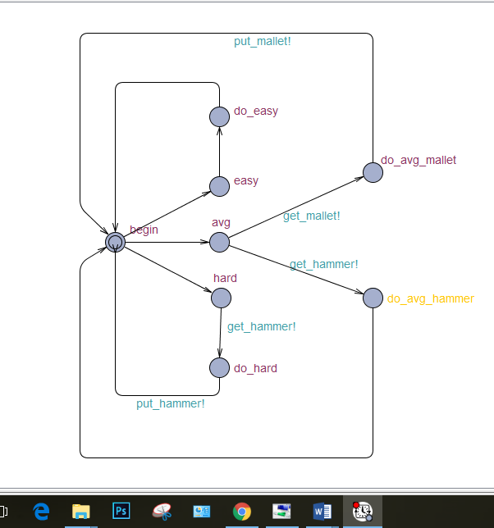

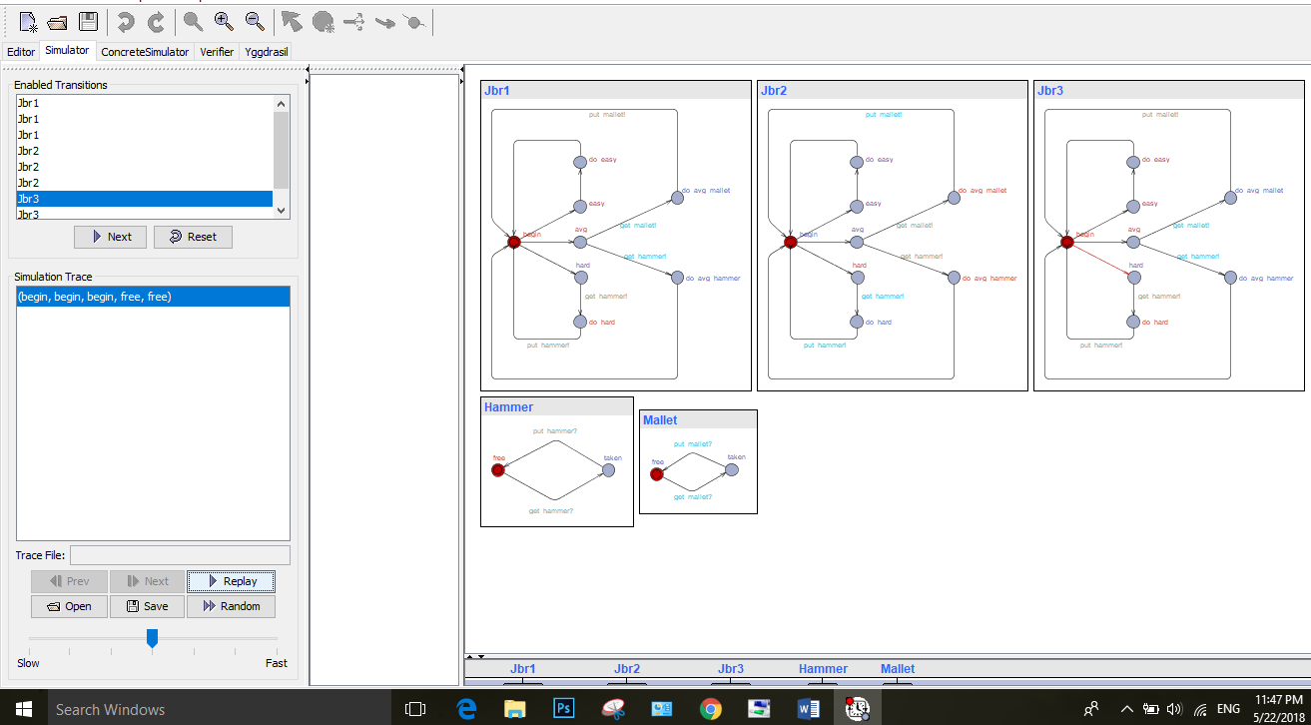

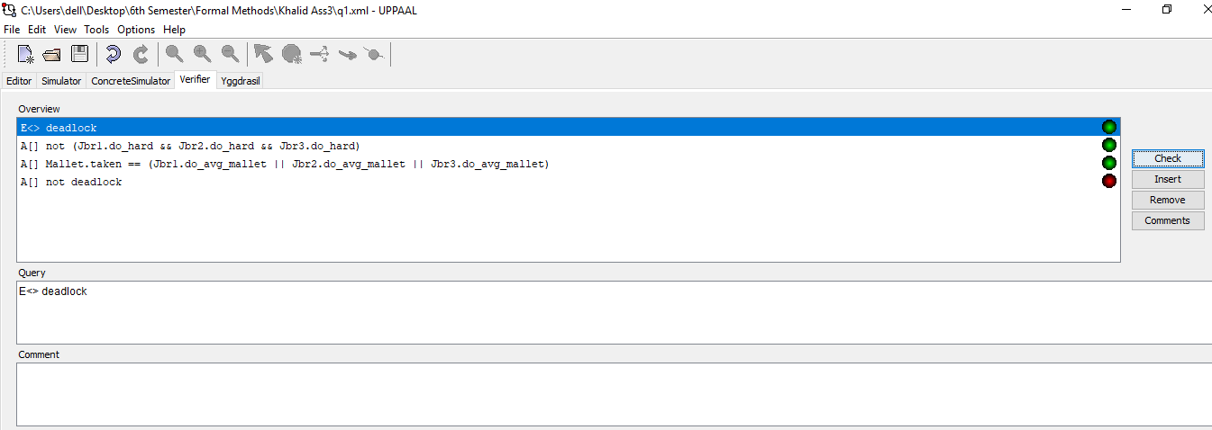

**Question No:2**

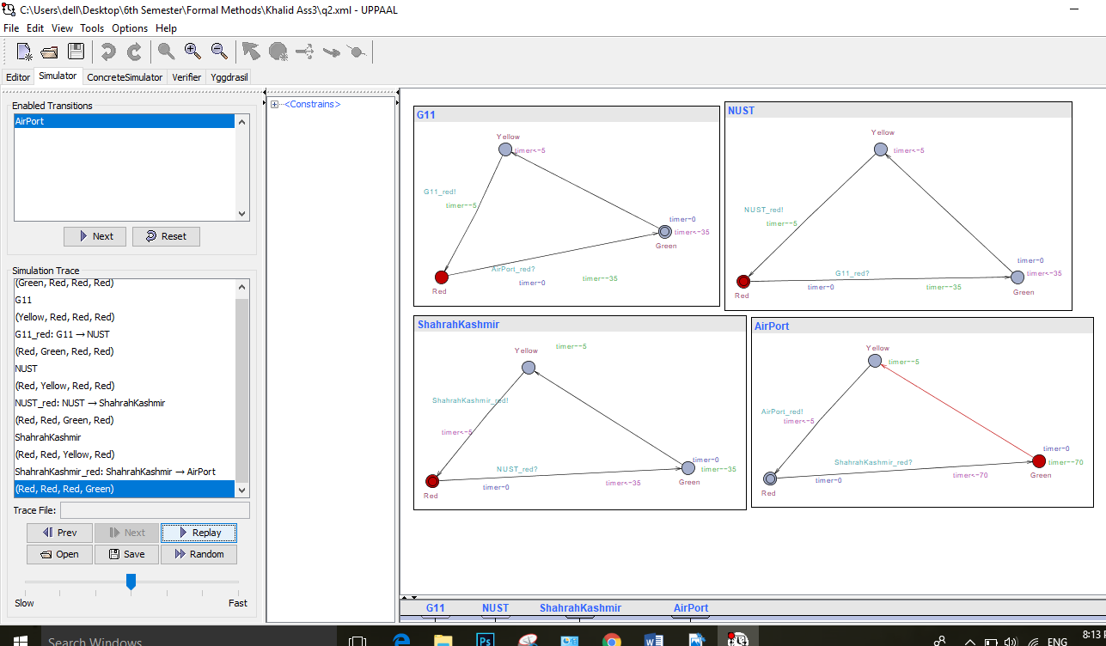

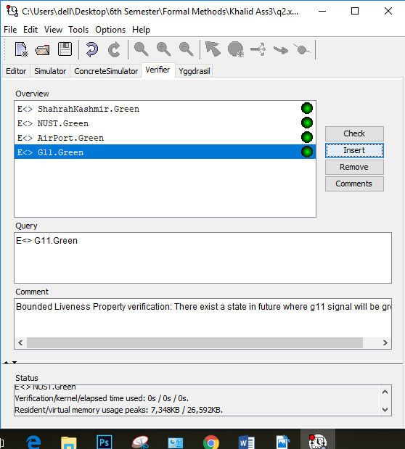

**Facebook Knowledge Sharing:**



